**Website Review Report: Eli Lilly**

By Olivia Flynn

Submission Date: 19/02/2019

Word Count: (800-1200 Words) 390

This report is a review of a publicly available website which belongs to a company which operates within the same industrial sector as my own employer; McKesson, Cork.

**Table of Contents**

Introduction___________________________________________________1

Website Structure______________________________________________2

Main Features of the Website___________________________________3

Website Critique_______________________________________________4

Summary______________________________________________________5

Appendix A: Referances_________________________________________6

**Introduction**

The website which will be reviewed belongs to Eli Lilly and Company (Eli Lilly, 2019). Eli Lilly and Company focus on five core global business areas: bio-medicines, diabetes, oncology, emerging markets and animal health. (Eli Lilly, 2019) They have been in business for over one-hundred and forty years and the commitments made by its founder include;

He would found a company that manufactured pharmaceutical products of the highest possible quality, his company would develop only medicines that would be dispensed at the suggestion of physicians rather than by travelling salesmen and Lilly’s medicines would be based on the best science of the day. (Eli Lilly, 2019)

Eli Lilly and Company are a global corporation and their product focus is for patients worldwide.

**Website Structure**

When a user visits the Eli Lilly website via its URL: (<https://www.lilly.ie/>), they first arrive on a homepage with many links to other pages of the website. There is large main navigation bar in red across the centre of the page and one smaller navigation bar to the top right hand corner which has a black background. The main navigation bar features the company logo and a search box. The user can visit about fourteen different pages based on the links which are visible from the home page, but this does not include the list option to change country from the map icon.

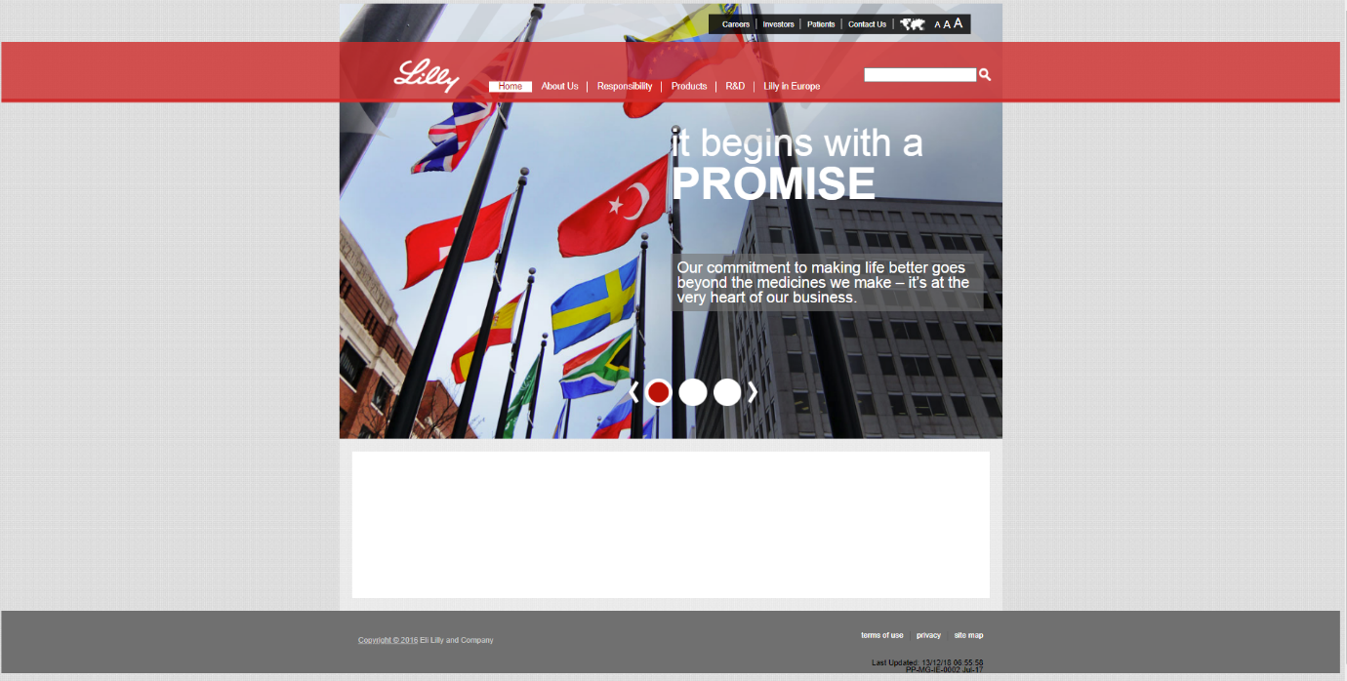

Figure 1: Eli Lilly Homepage

The homepage features a scrolling image behind the navigation with text in the form of headings and paragraphs overlaying the image.

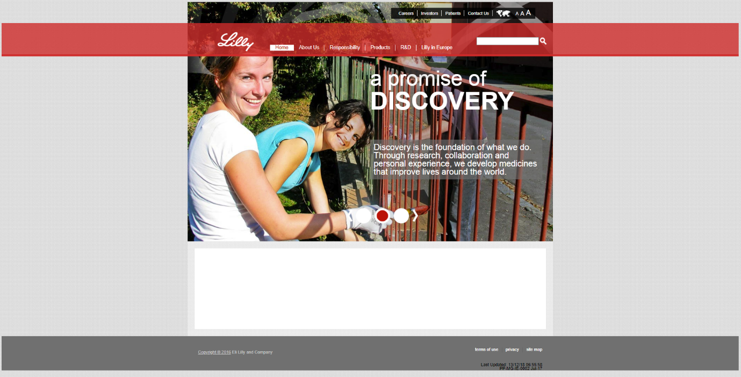

Figure 2: Second image on scrolling background image

**Sitemap for Eli Lilly Website**

Analysing the website with a site map tool returns a total of thirty five pages. The following graphic represents the index page in the long red box, folders in the navy boxes and various HTML pages in the multi-colour boxes.

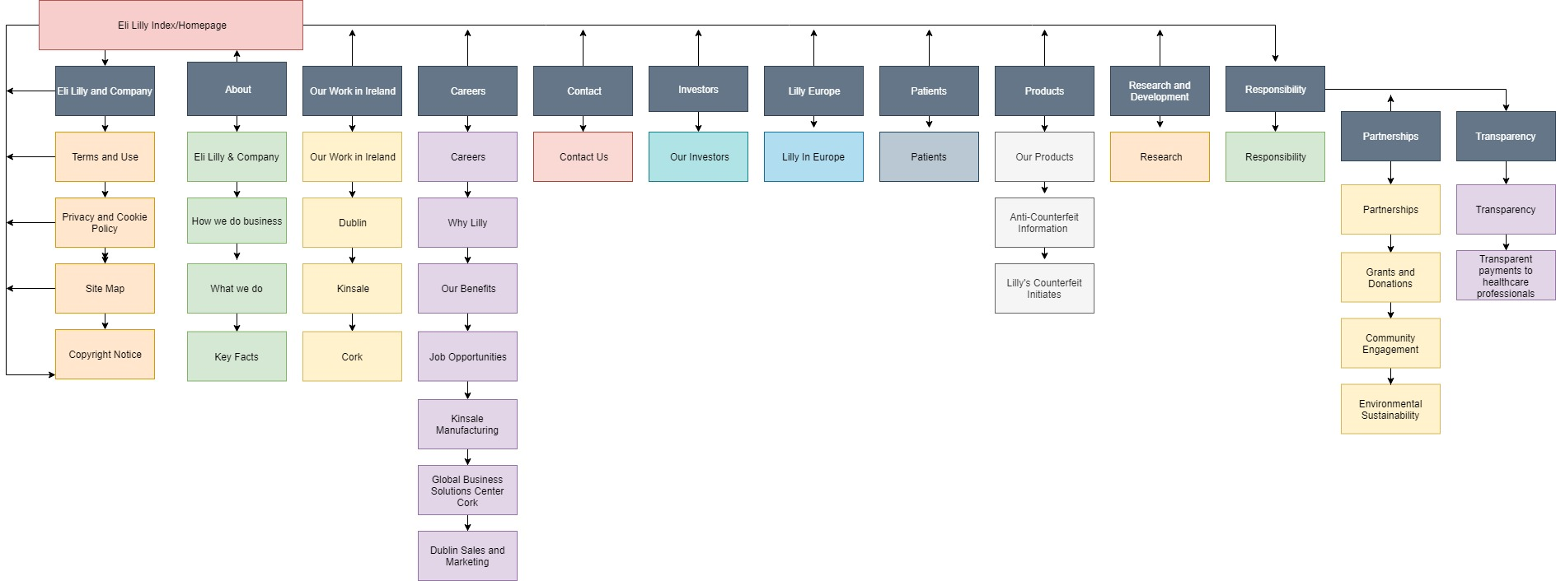

**Main Features of the Website**

**Website Critique**

There are a few areas in which the web developers of the Eli Lilly website could improve the website.

1. Empty box on homepage: When the source code is inspected, it can be seen that this was used for some kind of testing, it perhaps should not be on the home page. The code reads:



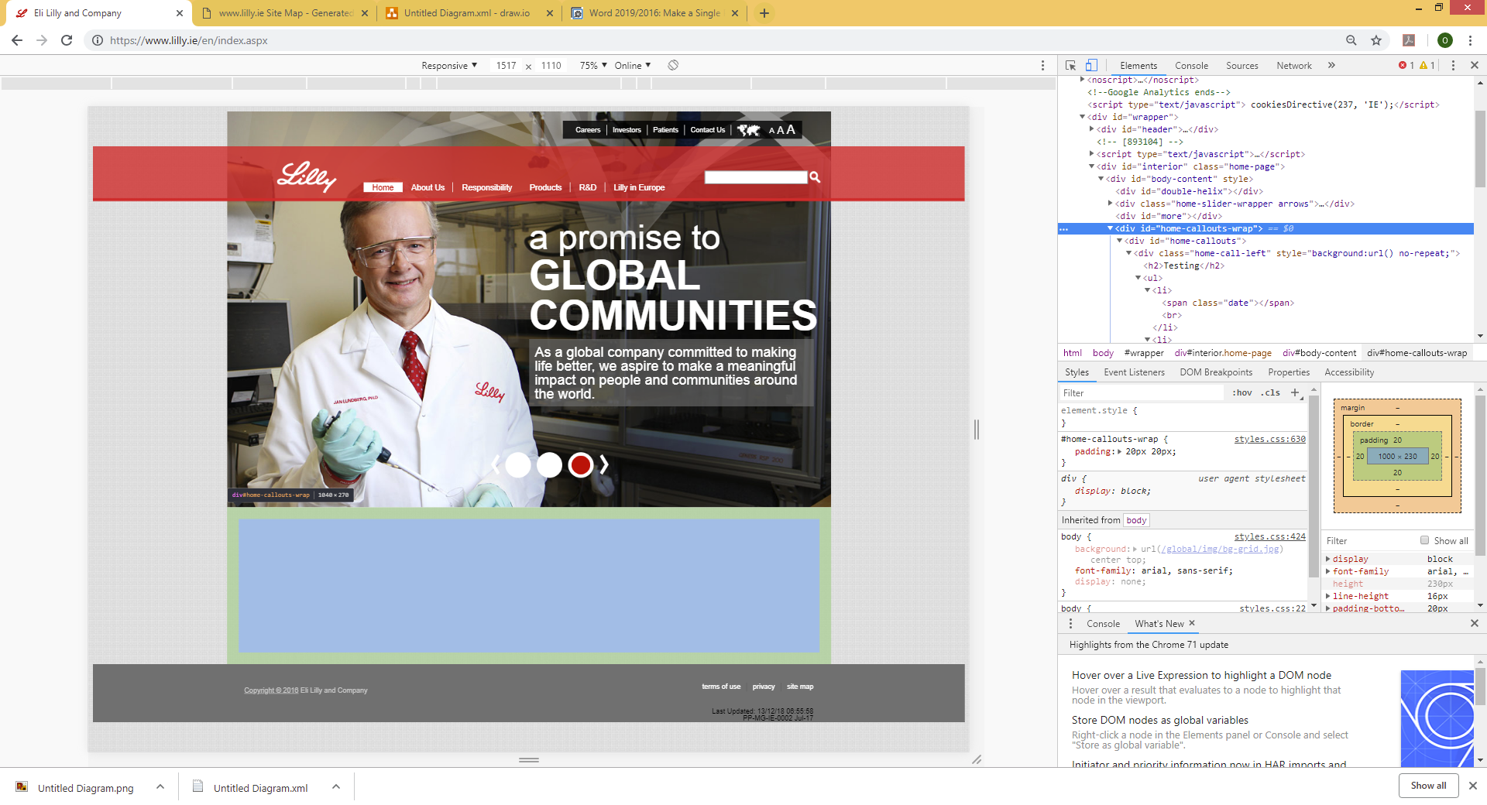

Figure 3- Empty box on homepage

1. 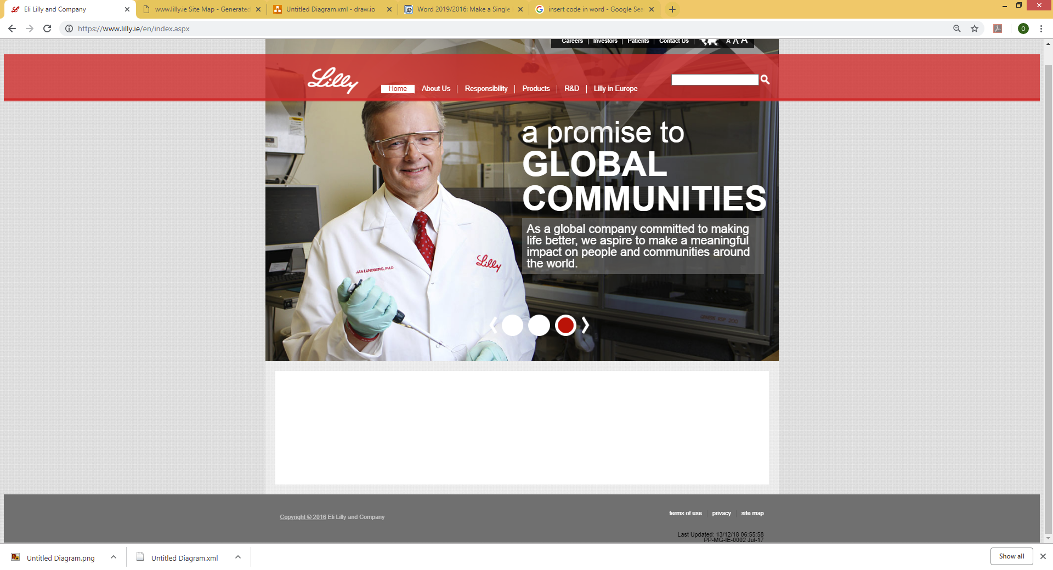Website copyright notice out of date: At the bottom of each of the sites pages, the copyright date is noted as 2016. As of writing it is 2019. To the far right of the footer there is some text which notes that last updating of the website to be in December 2018. This shows poor attention to detail and it is unclear why the copyright notice does not update when the websites content does. This should be a Javascript which updates the date based on the current system.

Figure 4- Outdated copyright information

1. Main navigation bar hover effects: The main navigation bar for the website features a hover over effect which is not very aesthetically pleasing. When a link is hovered over, the navigation bar extends out into a large red rectangle which overlaps the homepage banner with the company logo.

**Summary**

To summarise, the EIi Lilly website is very straightforward to use but it is lacking a certain amount of quality which would be expected from a large company’s website.

**Appendix A: References**

Eli Lilly, 2019. *About.* [Online]   
Available at: https://www.lilly.ie/en/about/index.aspx  
[Accessed 21 January 2019].

Eli Lilly, 2019. *Eli Lilly and Company.* [Online]   
Available at: https://www.lilly.ie/en/index.aspx  
[Accessed 21 January 2019].